Framework for Increasing Groundwater Replenishment & Achieving Sustainability

DRAFT VERSION: July 23, 2019

Association of California
ACWA’s mission is to assist its members in promoting the development, management and reasonable beneficial use of good quality water at the lowest practical cost in an environmentally balanced manner.
Water Agencies

Contacts and Location:
Sacramento Office
910 K Street, Suite 100
Sacramento, CA 95814
916.441.4545
Brent Hastey
ACWA President
Steve LaMar
ACWA Vice President
Dave Eggerton
Executive Director

©2019 by Association of California Water Agencies
www.acwa.com
All rights reserved.

Executive Summary

[To be added]

Introduction
The Association of California Water Agencies (ACWA) has prepared this framework in response to a growing need to address unsustainable groundwater levels statewide through increased groundwater replenishment activities. Basins throughout California are currently designated as high and medium priority basins as well as critically over-drafted. Many of these basins are impacted by undesirable results such as lowering groundwater levels, local subsidence, and degraded groundwater quality. There is widespread recognition that further action will be required to promote and achieve groundwater sustainability statewide. This framework summarizes the tools and resources, as well as a narrative framework and checklist for water managers to consider as groundwater recharge projects and activities are further developed.

Legislative Background

In 2014, former Governor Jerry Brown signed into law a three-bill legislative package, composed of AB 1739 (Dickinson), SB 1168 (Pavley), and SB 1319 (Pavley), collectively known as the Sustainable Groundwater Management Act (SGMA).

With the enactment of SGMA and for the first time in California water history, a regulatory framework was set forth for the sustainable management of groundwater basins over a 20-year planning and implementation horizon. SGMA requires local governments and water agencies of high and medium priority basins to form groundwater sustainability agencies (GSAs) to develop groundwater sustainability plans (GSPs). The GSPs will present a roadmap for how GSAs will halt overdraft and undesirable results and bring groundwater basins into balanced levels of pumping and recharge.

This framework document builds on the Association’s Board-adopted Groundwater Management Policy Principles (March 2009), ACWA’s landmark document, “Sustainability from the Ground Up: A Framework for Groundwater Management in California” (April 2011), and ACWA’s “Recommendations for Achieving Groundwater Sustainability” (April 2014). Each of these documents provide an in-depth look at groundwater management in California with recommended proactive steps to overall advance groundwater sustainability.

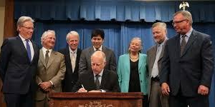
The implementation of this framework will support local water managers to identify the potential for and enhance current groundwater recharge activities, significantly improve groundwater management capabilities where they are deficient, accelerate the achievement of sustainability by local and regional entities, and guide state support where needed.

Policy Context for Groundwater Replenishment
The following policy context is derived from ACWA’s “Recommendations for Achieving Groundwater Sustainability” (April 2014) Report. These fundamental components to groundwater management must be advanced by local GSAs statewide to ensure an increase in groundwater replenishment and achieve groundwater sustainability throughout California.
Promote Local Management: Continue groundwater basins management by local and regional agencies with input from local stakeholders through GSAs and development of GSPs.

Increase Groundwater Storage: Increase surface water in underground storage basins and develop significant new groundwater storage and conjunctive use projects to optimize use of the state’s limited and highly variable water supplies.

Remove Impediments to Recharge: Coordinate and plan to use surface water, recycled water, stormwater and groundwater resources to maximize the availability and reliability of water supplies.

Avoid or Minimize Subsidence: Identify areas where groundwater pumping is resulting in subsidence at levels causing damage or risk of damage to overlying infrastructure and increase additional land use planning, engineering, and capital improvements, monitoring and reporting requirements.

Improve Data Availability: Collect appropriate data and make it publicly available both locally and at the state level.

Assess Groundwater Connection to Surface Waters: Evaluate the relationship of surface water sources and groundwater levels and quality in basins and identify the impacts, if any, on surface water sources and its related public benefits.

Provide State Financial and Technical Assistance. Encourage the state, through DWR, to continue to provide significant new financial assistance and technical support to local and regional agencies for improving or developing GSPs and implementing replenishment projects. Developing management capacity in currently critically overdrafted basins should be the first priority.

Groundwater: A Current Landscape

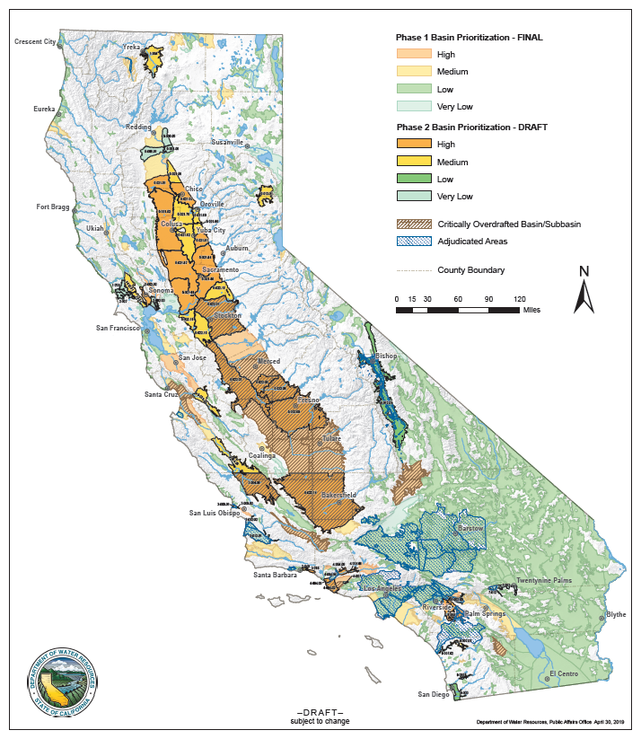
SGMA requires governments and water agencies of high and medium priority basins to halt overdraft and bring groundwater basins into balanced levels of pumping and recharge. Under SGMA, these basins should reach sustainability within 20 years of implementing their sustainability plans. For critically over-drafted basins, that will be 2040. For the remaining high and medium priority basins, 2042 is the deadline. In his signing statement, former Governor Brown emphasized that “groundwater management in California is best accomplished locally.” Currently, local GSAs are preparing their GSP for the first deadlines in 2020 and 2022. The GSPs will contain critical information related to groundwater replenishment opportunities based on groundwater conditions, monitoring activities, projects and management actions and areas of uncertainty and data gaps.
As reported in several recent Public Policy Institute of California (PPIC)’s studies, the San Joaquin Valley is “ground zero” for implementing SGMA, where since the mid-1980’s the valley’s average annual overdraft is nearly 2 million-acre-feet per year (or 13% of net water use).
Basin Prioritization
California’s 515 groundwater basins are classified into one of four categories: high, medium, low or very-low priority based on components identified in the California Water Code Section 10933(b):
- Population
- Rate of population growth
- Number of public supply wells
- Total number of wells
- Total irrigated acreage
- Degree to which persons overlying the basin rely on groundwater as their primary source of water
- Documented impacts on the groundwater within the basin, including overdraft, subsidence, saline intrusion, and other water quality degradation
- Any other information determined to be relevant by the department, including adverse impacts on local habitat and local streamflows
During the prioritization process, the best available datasets and information are applied in a consistent, statewide manner. Basin prioritization is critical in determining which provision under SGMA apply to specific basins. The current basin prioritization map is shown below and can be found on DWR’s website.
Critically Overdrafted Basins
As defined in California Water Code Section 10735(a) “Condition of long-term overdraft” means the condition of a groundwater basin where the average annual amount of water extracted for a long-term period, generally 10 years or more, exceeds the long-term average annual supply of water to the basin, plus any temporary surplus. Overdraft during a period of drought is not sufficient to establish a condition of long-term overdraft if extractions and recharge are managed as necessary to ensure that reductions in groundwater levels or storage during a period of drought are offset by increases in groundwater levels or storage during other periods.

However, in many areas of California, overdraft has been and continues to be exacerbated by a significant reduction in available surface water supplies over the past two decades. As PPIC notes, the inability of the State Water Project and the federal Central Valley Project to reliably deliver contracted water supplies has eliminated a substantial amount of surface water that once played a key role in recharging groundwater basins. In many cases, demand for groundwater is directly related to the reliability and availability of surface water supplies. The loss of reliable surface water supplies means that past investments in local and regional water systems – and the agricultural, urban and environmental water uses long supported by conjunctive management of surface water and groundwater resources – are now at risk.

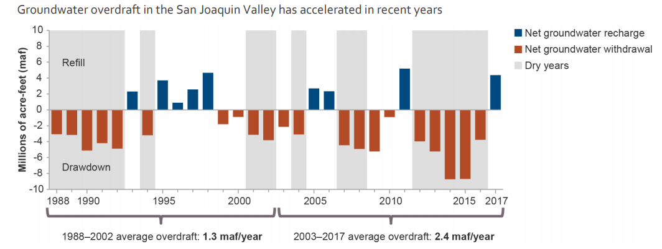
PPIC Report – Note: “Dry years” are those classified as dry or critically dry for the San Joaquin Valley.

Recent PPIC Studies related to Groundwater Management
“Water and the Future of the San Joaquin Valley” – February 2019
“Managing Drought in a Changing Climate: Four Essential Reforms” – September 2018
“Replenishing Groundwater in the San Joaquin Valley” – April 2018

In the 2013 Update of the California Water Plan, a survey was completed by ACWA and DWR and there were 89 active conjunctive management and groundwater recharge programs identified statewide (Note: data reflects active conjunctive management agencies identified by DWR as of July 2012 and may not represent all conjunctive management agencies in California).
ACWA recently conducted a survey of local groundwater managers to evaluate measurable progress on conjunctive use and recharge activities. A comparison of the quantified details are outlined in Table 1 below, contrasting survey data from 2013 to 2019. Of significant relevance is the historic passage of SGMA in 2014 between the 2013 and 2019 survey dates.

[Insert a map of 2019 groundwater recharge locations as reported in survey]

[Insert narrative, tables and bar charts with survey results, comparing the 2013 and 2019 conjunctive management activities.]

ACWA Framework for Groundwater Replenishment
This framework provides the context for the financial, technical, institutional, and administrative aspects that GSAs and local entities should consider when planning and developing groundwater replenishment activities. The following framework suggests a comprehensive approach to the development of groundwater replenishment projects as GSAs develop their GSPs, groundwater management projects, and other groundwater replenishment activities.

Financial Considerations to Evaluate
Cost considerations for the development of new supplies is a critical component in evaluating the viability of any groundwater replenishment project. Most GSA’s evaluate the cost of a project, for comparison to other potential water supply projects, on a dollar per acre-foot basis ($/AF). The financial aspect of any proposed groundwater replenishment project is evaluated dividing the anticipated water supply benefit of the project by the total capital and annual operating cost of the project divided by the anticipated water supply benefit or yield.

While capital costs can be developed, the greatest challenge in evaluating the potential cost benefit of the proposed project is the quantification of water supplies available for replenishment. Many of these projects rely upon low cost/high flow water, which can be highly variable. Evaluating and scoping a project’s financials requires a method of evaluation as well as developing metrics. The method for evaluating a potential recharge project includes projecting a projected average yield of water, and the frequency or volume to calculate the dollar per acre-foot cost. The metric evaluation includes comparing different alternatives to the scoped project to determine the scaled price of that investment.

Technical Considerations to Identify
There are various technical considerations when developing groundwater replenishment activities, including the identification of a water supply source, infrastructure needs and constraints, recharge methods, and appropriate recharge locations. To be able to increase groundwater recharge, a water source is required. Rather, local and state entities should be flexible in managing existing water supply sources with new ways. This could include utilizing stormwater or recycled water for recharge purposes as innovative approaches to reusing stormwater runoff or wastewater. Further, when California experiences peak flood years, a process should be established for capturing high or excess flows in riverine systems that would not impact instream flows or beneficial uses and continues to protect downstream water rights holders. Additionally, local as well as the state and federal water project operations could also be adapted to leverage existing surface water supply sources for purposes of recharging groundwater basins. Finally, leveraging the asset through partnerships with other water rights holders may provide access to new water. For example, a partnership to bank and reregulate water on behalf of an out of basin or out of region interest may provide access to new water through an unbalanced exchange.

Conveyance and Recharge Infrastructure. Other technical aspects to consider when developing groundwater recharge projects include what infrastructure is needed to capture and convey available water including the maintenance of SWP and CVP infrastructure, as well as locally operated infrastructure, as needed. Such infrastructure could include interties for water trading, injection wells, recharge ponds, and conveyance for capturing high or excess flows from riverine systems. It is also important to consider the appropriate recharge locations when developing recharge activities. This requires an understanding of the physical conditions of the surface and subsurface environment, soils and geology, as well as land acquisition or land use planning decisions and constraints. An emerging strategy for integrating agricultural water use with additional recharge benefits is to use flood-MAR techniques on existing agricultural lands or croplands.

In-Lieu Recharge. These technical and infrastructure needs relate to direct recharge practices. However, for groundwater-dependent communities, acquiring additional surface water supply sources could be used to offset the need to use groundwater sources. This is called in-lieu recharge and is another method of allowing recharge to occur naturally overtime by leaving water in a groundwater basin. This type of conjunctive water management planning will be integral in developing solutions to achieve the sustainable yield in groundwater basins.

Institutional Considerations to Navigate
To be able to employ the technical aspects of groundwater recharge, the ability to navigate institutional considerations is essential. Such institutional considerations include how the water rights system affects recharge activities in a basin and with whom to develop partnerships.

A general understanding of the current operations and constraints of the State Water Project (SWP) and the Central Valley Project (CVP) is critical in identifying how to use existing water supplies differently for optimal groundwater recharge purposes.

Article 21 Water. The California Department of Water Resources (DWR) manages the long-term contracts with 29 local water supply entities who receive surface water supplies from the SWP. Table A amounts are the maximum annual SWP amounts in acre-feet of water delivered to the contractors. Water available for delivery that is non-Table A is called Article 21 water and is identified in the water supply contracts as water that becomes available on an intermittent basis. Article 21 water is considered excess water in the system. Delivery of Article 21 water cannot impact the Table A allocation of any of the contractor’s water, nor can it negatively impact SWP operations. A contractor cannot defer their Table A allocation because they are getting Article 21 water. The process for determining Article 21 water availability and allocation begins with DWR’s SWP Operations Office determining how much water will become available based on forecasted and existing hydrology and then contracts are put in place. Once allocated, DWR then monitors demands on a weekly basis.

Section 215 Water. Similarly, the Bureau of Reclamation (Bureau) manages the agreements related to the CVP. The Reclamation Reform Act of 1982 includes Section 215, which authorizes the Bureau to provide temporary water service contracts. Section 215 water becomes available because San Luis Reservoir is full and the Jones Pumping Plant’s export capacity exceeds south of Delta service area demands. As an example, in 2018 the Bureau proposed to execute 215 water service contracts with CVP and non-CVP contractors within Friant’s CVP Place of Use (a determined service area). The contract amounts were based on the availability of Section 215 water and managed at the Bureau’s discretion, depending on reservoir capacity and operations, and hydrologic conditions. There were several conditions placed on the 2018 Section 215 water contracts, such as the water could be used for irrigation, municipal and industrial purposes and must be used within the contractor’s water service boundary and Friant’s Place of Use. No banking, transferring, or exchanging of Section 215 water was allowed unless otherwise approved by the Bureau. These contractual limitations are important in understanding the timing, yield, frequency and cost of available water coming from the SWP and the CVP.

Partnerships. The relationships between current water rights holders is key to developing recharge projects. As on-farm recharge and other flood-MAR techniques become more widely practiced, individual landowners will be an increasingly important stakeholder to engage with in obtaining and managing water rights and delivering water. Landowners should be considered partners who can help address groundwater recharge based on coordinating their land uses with water agencies or GSAs who have the expertise, water rights and infrastructure to support groundwater replenishment activities. Coordination between basins or sub-basins will also be necessary, so as to not adversely impact neighboring basins or specific areas where there is interconnected surface water and groundwater. Therefore, a priority relationship to foster will be between surface water and groundwater users to develop potential future agreements. Coordination with local entities and state agencies will be important for acquiring permits, water rights, and for environmental planning purposes to manage critical habitat and biological species, such as through safe harbor agreements, habitat conservation plans (HCPs), or natural community conservation plans (NCCPs).

Administrative Considerations to Advance
There are other administrative aspects for GSAs and local entities to consider when moving forward with planning for groundwater recharge projects. The State Water Board’s proposed streamlined permit to capture excess flows could be a tool for local entities to utilize once it becomes available. DWR provides grant funding, technical and facilitation support services that could be used to support GSAs working to develop recharge projects. The GSAs have statutory fee authority for when there is a need for additional funding to support recharge efforts. When GSAs make developments in these technical, institutional, and administrative areas, the GSPs should be updated to incorporate this information as planned actions to increase replenishment activities.

ACWA Checklist for Groundwater Replenishment
The checklist below includes the technical, institutional, and administrative considerations. This checklist does not outline all possible challenges, but provides an initial list from which water managers can start evaluating locally-relevant considerations, and develop basin-specific groundwater recharge proposals and activities in the Projects and Management Actions section in the GSPs.

Financial Considerations
- Scoping the funding for project development, including capital costs, operating costs and water supply cost & yield

Technical Considerations
- Sources of water supply
  - Contractual limitations
- Infrastructure needs and constraints
  - Conveyance accountability and timing of releases
  - New local infrastructure, if needed
- Various recharge methods
  - Direct recharge or in lieu recharge
  - Direct recharge methods includes various methods such as injection wells, recharge ponds, and flood-MAR techniques
- Appropriate direct recharge locations
  - Land use acquisition or land use planning decisions and constraints
  - Physical conditions of the surface and subsurface environment, soils and geology
  - Place of use and water quality considerations of source water supply

Institutional Considerations
- How the water rights system affects recharge projects
  - Current water rights holders and consideration of individual landowners obtaining water rights (balance water rights to ensure groundwater availability for beneficial uses/users)
- Navigating partnerships
  - Coordination between basins
  - Communication between surface water districts and groundwater users
  - Potential agreements between individual landowners and water agencies (beneficiaries)
  - Coordination with state agencies related to permits, water rights, and environmental planning purposes
- Other regulatory barriers to developing such recharge projects
  - Legal or procedural operation agreement constraints

Administrative Considerations
- Contractual aspects such as the necessary water rights
  - State Water Board’s streamlined permit to capture excess flows
- Funding mechanism to successfully implement recharge projects
  - Grant funding, technical assistance, facilitation services, GSA fee authority, etc.
  - Funding for local staffing to manage recharge activities
Comprehensive Toolbox Approach
With the overall goal to increase groundwater replenishment activities in groundwater basins statewide, water managers need to use a comprehensive toolbox approach. It will take most, if not all of the tools in a water manager’s toolbox to achieve sustainability. GSAs across California have different undesirable results impacting their basins and sub-basins. Local water agencies will need to continue to manage their water supplies creatively and conjunctively to meet supply demands but also reduce dependence on groundwater sources. Below are several resources to serve as tools for water managers when scoping and develop groundwater recharge projects and activities.
[INSERT PICTURE FROM YOLO FROM TEMPORARY PERMITTING]
Temporary Water Rights Permit to Capture High Runoff
On April 6, 2017, former Governor Jerry Brown signed Executive Order B-39-17, which directs the State Water Board to prioritize temporary water right permits for projects that enhance the ability of a local or state agency to capture high runoff events for local storage or recharge. The Executive Order also suspends the provisions of the California Environmental Quality Act (CEQA) for State Water Board actions on these types of temporary permits. Prior to Executive order B-39-17, the former Governor issued Executive Order B-36-15 in November 2015, which contained a similar directive.

Proposed Streamlined Water Rights Permit for Groundwater Recharge
Over the last several years, the State Water Board has been developing additional administrative information on the water rights aspect of capturing surface water to recharge groundwater basins. State Water Board staff are in the process of developing guidance that proposes an approach for the streamlined processing of “standard” water rights applications to divert and capture high flows to underground recharge. The proposed approach under development will not change any existing laws or regulations and will focus primarily on the water availability analysis aspect of application processing. The types of projects intended to be covered would focus on an applicant who is a GSA or local agency for projects consisting of diversions during periods of high flows (to be defined in the guidance) between December 1 and March 31. Final State Water Board guidance is anticipated to be released by summer 2019. More information can be found at their Water Rights for Groundwater Recharge webpage.

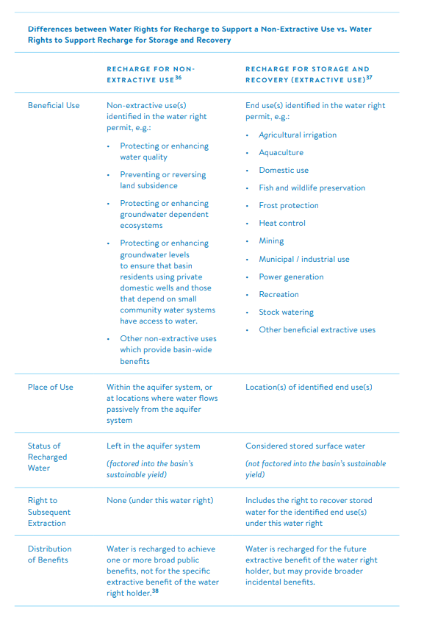
Diagram provided by the University of California, Berkeley Center for Law, Energy & the Environment.
Fact Sheets
As helpful resources prior to the release of the streamlined permit guidance, the State Water Board developed several fact sheets related to groundwater recharge:
- Purposes of Use for Underground Storage Projects
- Flood Control, Groundwater Recharge, and Water Rights

Berkeley Law Issue Brief
The University of California, Berkeley Center for Law, Energy & the Environment published an issue brief in August 2018 titled, “When Is Groundwater Recharge a Beneficial Use of Surface Water in California?” The issue brief helps define the conditions under which recharge for non-extractive purposes is a beneficial use and encourages the State Water Board to develop such guidance as they are pursuing now. The following chart is a helpful summary from the extractive and non-extractive uses.

Proposed 5-Year Temporary Permit
Over the last several years, the Legislature has proposed a legislative solution to developing a temporary water rights permit to capture high-flow events, similar to the executive order but allowing the temporary permit to span multiple years. These legislative proposals have included AB 1427 (Eggman) which became a two-year bill in 2017 and AB 2649 (Arambula) which was gutted-and amended at the end of session in 2018. This year, AB 658 (Arambula) would authorize a GSA or local agency to apply for, and the State Water Board to issue, a conditional 5-year temporary permit to divert surface water during high-flow events for underground storage for beneficial use that advances the sustainability goal of a groundwater basin. If passed by the Legislature, the 5-year temporary permit could be acquired first by a local agency or GSA to how feasible it is to capture and divert excess surface water. Then the local agency or GSA could pursue the permanent streamlined water rights permit.
Flood Managed Aquifer Recharge (Flood-MAR)
“Flood-MAR” is an integrated and voluntary resource management strategy that uses flood water resulting from, or in anticipation of, rainfall or snow melt for managed aquifer recharge (MAR) on agricultural lands and working landscapes, including but not limited to refuges, floodplains, and flood bypasses. Flood-MAR can be implemented at multiple scales, from individual landowners diverting flood water with existing infrastructure, to using extensive detention/recharge areas and modernizing flood management infrastructure/operations.
Flood-MAR projects can provide broad benefits for Californians and the ecosystems of the state, including:

- Water supply reliability
- Flood risk reduction
- Drought Preparedness
- Aquifer Replenishment
- Ecosystem Enhancement
- Subsidence Mitigation
- Water Quality Improvement
- Working Landscape
Preservation and Stewardship
- Climate Change Adaptation
- Recreation and Aesthetics

There is strong, and growing, interest across the state in understanding the benefits, limitations, concerns, costs, and funding opportunities for Flood-MAR projects. DWR is working with other state, federal, Tribal, and local entities, academia, and landowners. Their white paper can be found here. More information can be found on DWR’s website. Flood-MAR is a multi-benefit technique that can be used by GSAs when identifying ways to replenish basins.
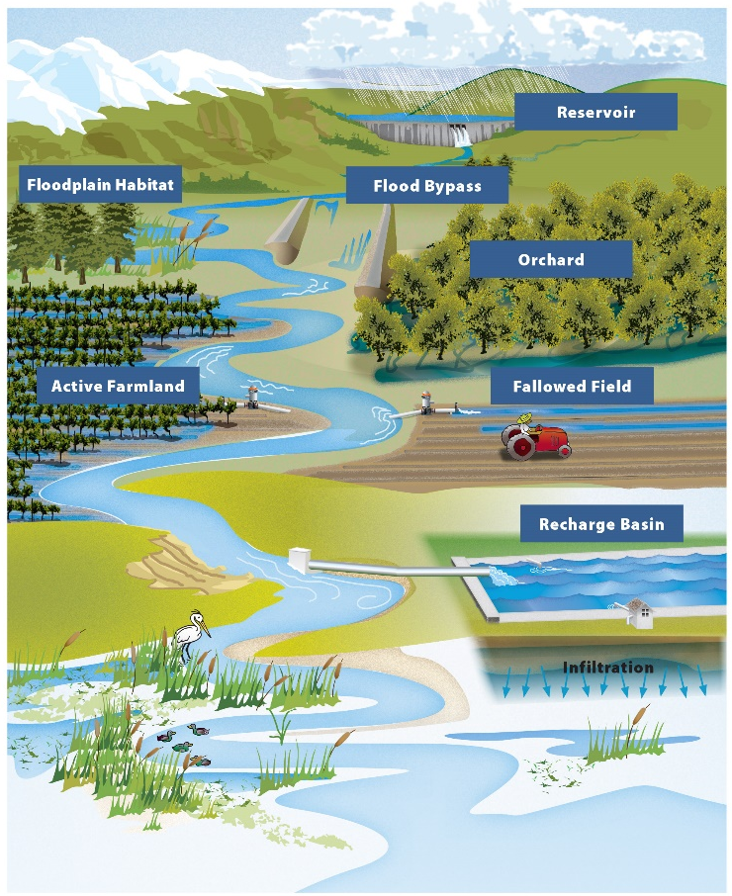
Flood-MAR image provided by the California Department of Water Resources.
Groundwater Recharge Assessment Tool (GRAT)
GRAT provides irrigation districts and GSAs with a decision support tool that will enable them to easily create and assess recharge scenarios. The tool enables water managers to evaluate where (active cropland, fallow land, and dedicated recharge basins), when (which weeks across multiple water year types, across a 20 year planning horizon) and how much water will be recharged based on best available data and hydrologic, agronomic and geologic science. It enables GSA’s to see their most cost effective options and consider the unintended environmental and social impacts in their basins. Sustainable Conservation has developed a fact sheet and instruction manual for the GRAT.
Groundwater Markets
On-Farm Recharge of Annual Crops & Waterbird Habitat Quick Reference Guide
The Migratory Bird Conservation Partnership developed an on-farm recharge of annual crops and water bird habitat reference guide. More information can be found online at: www.camigratorybirds.org.
The Nature Conservancy, working with the Fox Canyon Groundwater Management Agency, has prepared the first groundwater market to emerge under SGMA, called the Fox Canyon Groundwater Market. This report outlines the experiences of the local GSA and its partners, steps taken, and lessons learned in developing a unique, algorithmic groundwater market to match voluntary stakeholders who have high water supply with those who are in need of water for groundwater replenishment in their basin. PPIC also recently published a fact sheet on California’s water market in May of 2019, which concludes that information regarding water availability could help reform California’s overall water market.
Groundwater Dependent Ecosystem Tool
Identifying the groundwater dependent ecosystems and list of freshwater species located within groundwater basins can be used by GSAs to better evaluate the impacts in determining where and when to replenish groundwater basins and identify critical groundwater level thresholds to maintain to promote ecosystem health. The Nature Conservancy has also developed a Groundwater Dependent Ecosystems (GDE) Pulse Tool that provides data and information on how GDEs have changed over the last 30 years, trends in groundwater levels, and rainfall with an interactive map and charting interface.
Water Quality Impacts
Stanford’s Water in the West Program developed a report in Spring of 2019 entitled, A Guide to Water Quality Requirements under the Sustainable Groundwater Management Act. The report discusses at-length water quality considerations as they relate to SGMA but also provides some helpful context as it relates to groundwater recharge. The report recognizes that groundwater recharge and other forms of active aquifer management are important tools for sustainable groundwater management, with potential to improve both groundwater supplies and groundwater quality. However, the report also addresses that some research also indicates that groundwater recharge via recharge ponds and/or direct injection could have the potential to mobilize naturally occurring constituents or mobilize or expand contaminant plumes. These are considerations that GSAs could find helpful when exploring replenishment management activities.
“Recharge Roundtable Call to Action” Report
As a collaboration between the Groundwater Resources Association of California and the University of California Water Security and Sustainability Research Initiative, the “Recharge Roundtable Call to Action” Report aims to motivate focused actions that effect large quantities of recharge and produce regional benefits. The Recharge Roundtable participants and organizers produced a call to action, organized around several key questions and related action steps, including how much water is hydrologically available and how can hundreds to thousands of recharge projects be incentivized.

Case Studies
The following case studies show examples of how GSAs are developing multi-benefit ground water replenishment projects throughout California.
Colusa County, Managed Aquifer Recharge: Benefitting Aquifers, Farmers and Migratory Birds
Case study and image provided by The Nature Conservancy.
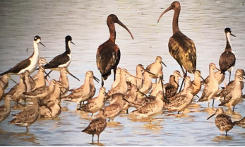
In partnership with growers and the Colusa Groundwater Authority (CGA), The Nature Conservancy (TNC) is implementing a pilot multiple-benefit managed aquifer recharge program on farmland in California’s Central Valley, Colusa County. This program will benefit local groundwater users by replenishing critical domestic and agricultural groundwater supplies in a Severely Disadvantaged Community (SDAC). Participating farmers will benefit economically through incentive payments, and migratory shorebirds will benefit through the creation of critical winter habitat on farms through our specific field and water depth specifications.
Modesto Irrigation District: Groundwater Replenishment Plan
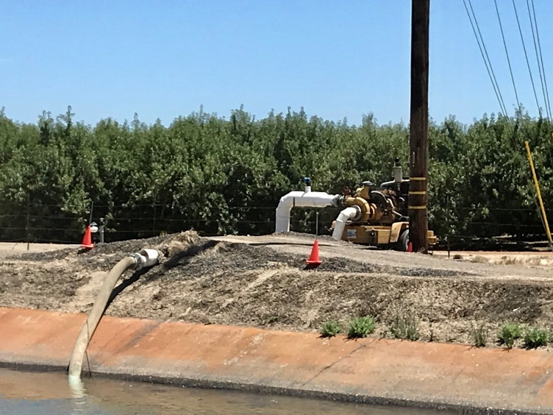
The Modesto Irrigation District Board of Director’s finalized their 2019 Groundwater Replenishment Plan – a voluntary plan that allows MID to deliver surplus surface water to any farmer with already developed agricultural land who is solely reliant upon groundwater within the Modesto Sub-basin and within MID’s existing sphere of influence. This surface water is for agricultural use only and the participants must demonstrate that the surface water received is put to beneficial uses at all times. The GRP was constructed following an abundance of precipitation in 2019.

Sacramento County, Making Room for Recharge: Consumnes River Levee Removal and Floodplain Restoration
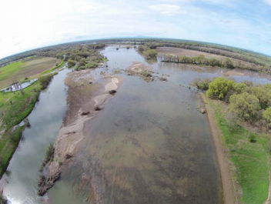
Reconnecting rivers to floodplains can facilitate groundwater recharge. A recent project along the Cosumnes River is one of the first to intentionally demonstrate this recharge benefit. While this project was expensive and more complex than many forms of recharge, public funding paid for the project and a partnership with UC Davis is improving the understanding of groundwater-surface water interactions and basin groundwater conditions. In 2014, The Nature Conservancy piloted this concept by selectively removing portions of a private levee system along the Cosumnes River to enhance floodplain processes and restore approximately 500 acres of riparian habitat. The levee removal project offers multiple environmental benefits, including increased groundwater recharge in the floodplain.
Case study and image provided by The Nature Conservancy.
Arvin-Edison Water Storage District, In-Lieu Program
Arvin-Edison Water Storage District (District) has developed an in-lieu groundwater program. When the District has available water supplies in excess of the current needs within their surface water service area, the avilable water supplies can be delivred to ‘In-Lieu Water User’ or landowners interested in in-lieu supplies. This program allows the District to reduce groundwater pumping and allow supplies to to recharge in their groundwater facilitites. Overtime the In-Lieu Program is an opportunity to improve and stabilize the groundwater conditions within the District.
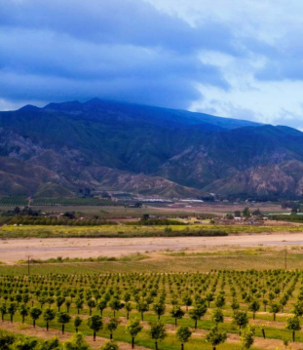
Ventura County, Treated Wastewater as a Multi-Benefit Groundwater Sustainability Project
The Arroyo Las Posas, a creek in Ventura County, is a good example of a stream supported by flows from a wastewater treatment plant (WWTP). These flows are a significant factor in the basin’s water balance and support important GDEs. How this treated water is used in the future may therefore play a significant role in planning for the basin’s groundwater sustainability. Recycled water from treated wastewater is recognized as an important source of water supply. Before proposing expensive water recycling projects though, water managers should consider the multiple benefits provided by the treated water being discharged to streams or rivers. As pressures increase to reuse this water to augment supplies, groundwater sustainability agencies (GSAs) should consider the potential negative impacts of discontinuing WWTP discharges to streams,
Case study and image provided by The Nature Conservancy.
including decreases in recharge and impacts to localized groundwater dependent ecosystems (GDEs).

Anticipated Challenges
With helpful tools and available resources for GSAs, replenishing California’s groundwater basins will still have anticipated challenges. The following are several critical challenges that must continue to be addressed in future discussions related to groundwater recharge:

Time is Essential. As defined under SGMA, GSAs have a 20-year planning and implementation horizon to bring basins into sustainable yield. However, time is essential when it comes to determining a balance ratio of extraction and recharge, in particular for basins that are already critically-overdrafted and in need of groundwater replenishment.

Changes in Groundwater Use. As is anticipated with water supply augmentation, a reduction in groundwater pumping may be necessary action for GSAs to take. This could impact drinking water for communities that are groundwater-dependent and agricultural practices that use groundwater as their primary water source. This could lead to a reduced amount of water available for agricultural use and eventual land fallowing. This could significantly impact California’s agricultural industry and economy at-large.

State and Local Coordination. Close coordination will be essential and will need to occur between state and local agencies to ensure that surface water supplies can be flexibly managed to maximize the amount of water that can be put towards recharging groundwater basins. Similarly, coordination between GSAs will need to occur to be able to ensure basin management activities between neighboring basins are not in conflict with one another.

Additional Funding. Some GSAs are already starting to begin processes to set rates under the GSA’s fee authority. However, future funding at the federal, state and local level needs to become available to incentivize and increase groundwater replenishment activities.

Statement of Commitment
ACWA and its member agencies have demonstrated a history of strong leadership in confronting and embracing needed changes to manage our groundwater resources in California. ACWA continues to be committed to working with the state and with urban and agricultural water users, growers and landowners, environmental and disadvantaged community interests, and other stakeholders on an effective approach to promote increased groundwater replenishment and achieve sustainable groundwater management throughout California.

ACWA’s Groundwater Replenishment Initiative

Task Force
Chair: Eric Averett, General Manager, Rosedale Rio Bravo Water Storage District
ACWA Staff Liaisons: Dave Bolland, Director of State Regulatory Relations
Melissa Sparks-Kranz, Regulatory Advocate
Task Force Members: Brent Hastey, ACWA President, Ex Officio Member

San Joaquin Valley
Chad Wegley, General Manager of Alta Irrigation District
Steven Collup, General Manager of Arvin Edison Water Storage District
Jeevan Muhar, Engineer-Manager of Arvin Edison Water Storage District
Chris White, General Manager of Central California Irrigation District
Alan Hofmann, General Manager, Fresno Metropolitan Flood Control District
Jason Phillips, General Manager, Friant Water Authority
Palmer McCoy, Executive Assistant at Henry Miller Reclamation District #2131
Curtis Creel, General Manager, Kern County Water Agency
Jon Parker, General Manager, Kern Water Bank
Paul Peschel, General Manager, Kings River Conservation District
Dan Vink, General Manager of Lower Tule River Irrigation District
Thomas Greci, General Manager of Madera Irrigation District
Matt Hurley, General Manager at McMullin Area Groundwater Sustainability Agency
John Sweigard, General Manager, Merced Irrigation District
Paul Hendrix, Manager, Mid-Kaweah Groundwater Sustainability Agency
Jake Wenger, Board Member, Modesto Irrigation District
Scott Furgerson, General Manager of Modesto Irrigation District
John Davids, Assistant General Manager of Water Operations, Modesto Irrigation District
Dave Orth, General Manager, North Friant Authority
Richard Diamond, General Manager, North Kern Water Storage District
Steve Chedister, Executive Director of San Joaquin River Exchange Contractors
Jason Peltier, General Manager, San Luis & Delta-Mendota Water Authority
Jason Gianquinto, General Manager, Semitropic Water Storage District
Tou Her, Assistant General Manager of Turlock Irrigation District
Bill Taube, Consultant, Wheeler-Ridge-Maricopa Water Storage District
Melissa Poole, Wonderful Company
Sacramento Valley
Thad Bettner, General Manager, Glenn-Colusa Irrigation District
David Guy, President, Northern California Water Association
Lewis Bair, General Manager, Reclamation District 108
John Woodling, General Manager, Executive Director, Sacramento Groundwater Authority
Greg Zlotnick, Water Resources Specialist, San Juan Water District
Jim Watson, Executive Director, Sites Joint Power Authority
Southern California
Peter Kavounas, General Manager, Chino Basin Watermaster
Jim Barrett, General Manager, Coachella Valley Water District
David Pettijohn, Manager Water Resources Development, Los Angeles Department of Water and Power
Roger Patterson, Assistant General Manager, Metropolitan Water District of Southern California
Mike Markus, General Manager, Orange County Water District
Shane Chapman, General Manager, Upper San Gabriel Valley Municipal Water District
Robb Whitaker, General Manager, Water Replenishment District of Southern California

